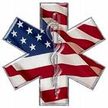
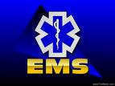
Central Iowa EMS Directors
2010 Meeting Schedule

Monday, January 25th, 2010
Location: Ankeny Fire Department
120 NW Ash Drive, Ankeny
Dinner: 1800
Meeting Time: 1830-2030

Monday, March 22nd, 2010
Location: Clive Fire Department
8505 Harbach Blvd., Clive
Dinner: 1800
Meeting Time: 1830-2030

Monday, May 24th, 2010
Location: Mercy West Lakes
1601 60th St, West Des Moines
Dinner: 1800
Meeting Time: 1830-2030

Monday, July 26th, 2010
Location: Urbandale Fire Department
3927 121st St, Urbandale
Dinner: 1800
Meeting Time: 1830-2030

Monday, September 27th, 2010
Location: Methodist West Hospital
1660 60th St, West Des Moines
Dinner: 1800
Meeting Time: 1830-2030

Monday, November 22nd, 2010
Location: Des Moines Fire Department Station #1
900 Mulberry
Dinner: 1800
Meeting Time: 1830-2030

